Please be advised, all out of state residents must mail in their application for License to Carry. Please make sure to include both the front and back of the application and be sure to fill it out completely. You must also include a copy of both the front and back of your driver’s license (address must match application) as well as a copy of the front and back of your License to Carry Firearms that was issued from the state that you reside in. This is for all new and renewal applications.

Please be sure to list references that will respond to our telephone call. Unreturned calls will delay the application process or result in the application not being approved.

Effective immediately, a check or money order payable to Wyoming County Sheriff in the amount of $5.00 is required in order to process your application.

Once your application is processed, we will call you to let you know if you were approved. If approved, you will need to schedule an appointment and appear in person within 45 days to complete the process.

Our office currently processes Licenses to Carry Monday through Friday 8:30 a.m. to 3 p.m. You must have an appointment – NO WALK INS!

If you have any questions, please feel free to contact our office at the number listed above.

Thank you for your cooperation with this matter.

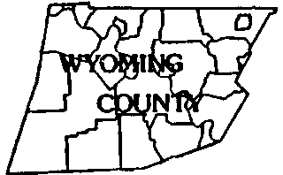


WYOMING COUNTY
SHERIFF'S OFFICE
SHERIFF: ROBERT L. ROBERTS,
(570) 996-2265
1 COURTHOUSE SQUARE
TUNKHANNOCK PA 18657
...
...

